**SCUOLA SECONDARIA STATALE DI PRIMO GRADO**







**“GIOVANNI BOVIO”**

**VIALE C. COLOMBO, 202 – 71121 FOGGIA**

|  |  |  |  |  |  |
| --- | --- | --- | --- | --- | --- |
| Tel. e Fax 0881/634000 | C.M. FGMM00400C | | C.F. 80030660718 | | Codice Univoco UF4537 |
| https://www.bovionlinefoggia.edu.it | | fgmm00400c@istruzione.it | | fgmm00400c@pec.istruzione.it | |

**  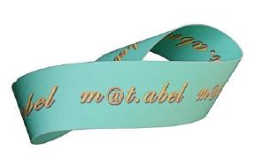

Prot.n. Foggia,

**Fonogramma**

**Trasmette**: __________________________________________________________

**Riceve: ______________________________________________________**

**Testo:**

___________________________________________________________________________________________________________________________________________________________________________________________________________________________________________________________________________________________________________________________________________________________________________________________________________________________________________________________________________________________________________________________________________________________________________________________________________________________________________________________________________________________________

Visto: Il Dirigente Scolastico

*Prof.ssa Milena Sabrina MANCINI*